Assignment for EE5101 Linear Systems:

Modeling and Control of a Stationary Self-Balancing Two-wheeled Vehicle

Name: XU Shulue

Matriculation Number: A0259887Y

Email Address: e0973729@u.nus.edu

Date: 11/11/2022

Abstraction:

Contents Table

1. **Introduction**
2. **System Modelling and Overall Design Requirement**
3. **System Controlling**
   1. **Control By All State Variables Using Pole Placement**

The aim of this section is to introduce a design of controller that can stabilize the system so that the output can converge to a non-specified final value, meanwhile satisfies the overall design requirement. Pole placement method is utilized to complete such a task in this section.

* + 1. Controller Design

The key of pole placement is to stabilize the system by placing the system poles to the negative-half of the s-plane. So one must specify the objective negative poles to be placed for a pole placement problem. Since the general requirements for overshoot and settling time have to be met, the chosen poles are as shown in Table 1.

|  |  |
| --- | --- |
|  |  |
|  |  |
|  |  |
|  |  |
|  |  |
|  |  |

**Table 1** The Six Stable Poles

Since the system is MIMO, unity rank method is leveraged to accomplish the task. Choose The vector to be , the unity rank system is created.

For the unity rank system, choose Ackermann’s formula as shown in Equation 1 for SISO pole placement. Here is shown as Figure 1.

Equation 1

The SISO system has gain is given as in .

Thus, the state feedback gain is given as in Figure 2.

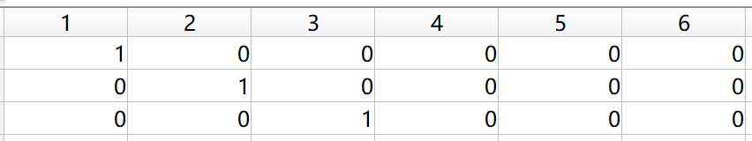

**Figure 1** Controllability Matrix of the Unity Rank System



**Figure 2** The SISO Gain

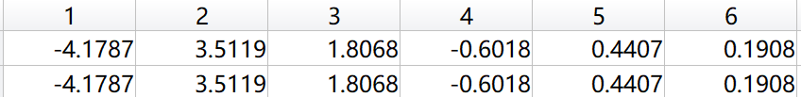

**Figure 3** The Feedback Gain

Fig demonstrates the design of overall controlled system with a flow chart.

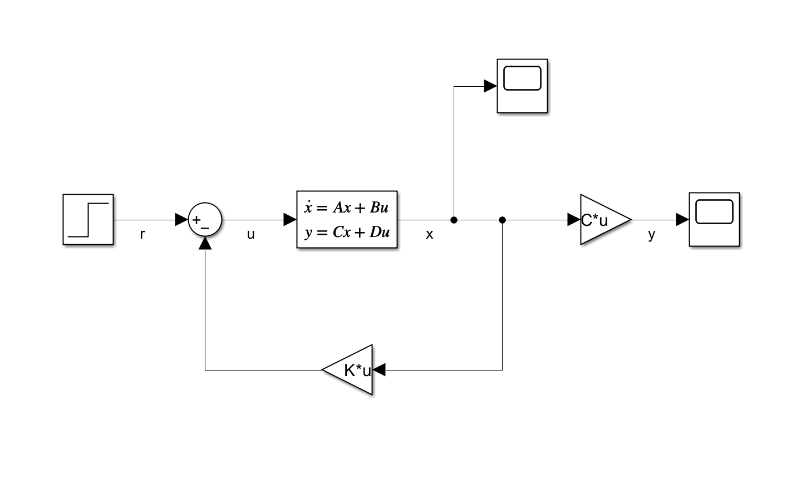

* + 1. Simulation Results

To check if the transient response of the closed-loop system meets the general requirements, let the reference input to be or . The simulation results for two cases are respectively shown in Fig and Fig.

For the zero input response with initial state being , the simulation result is shown in Fig.

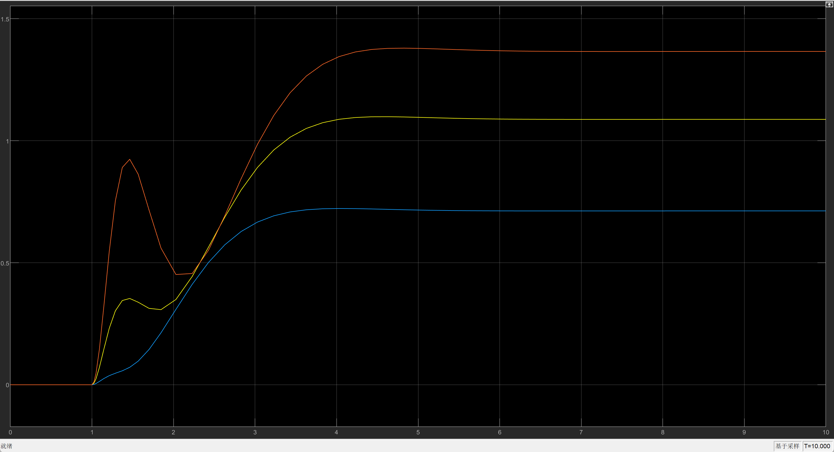

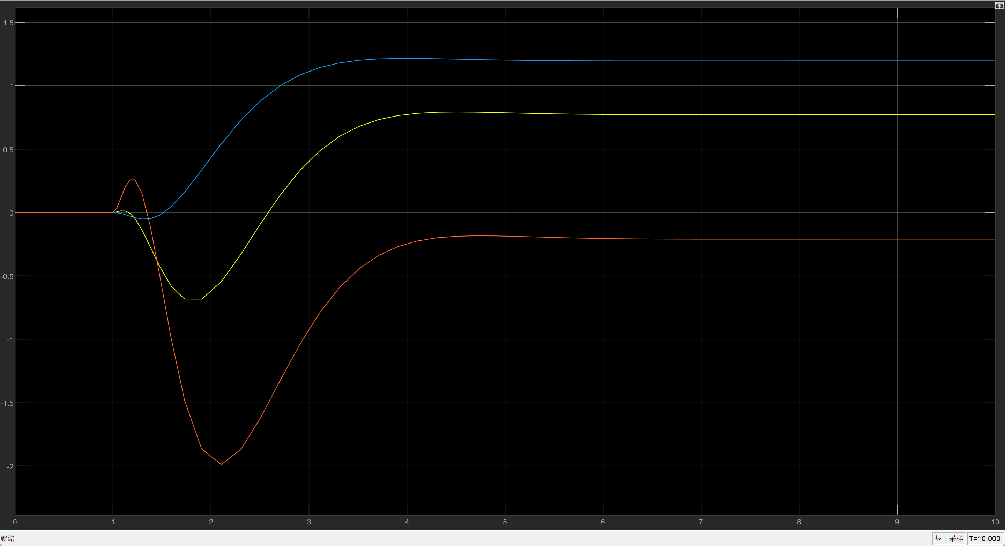

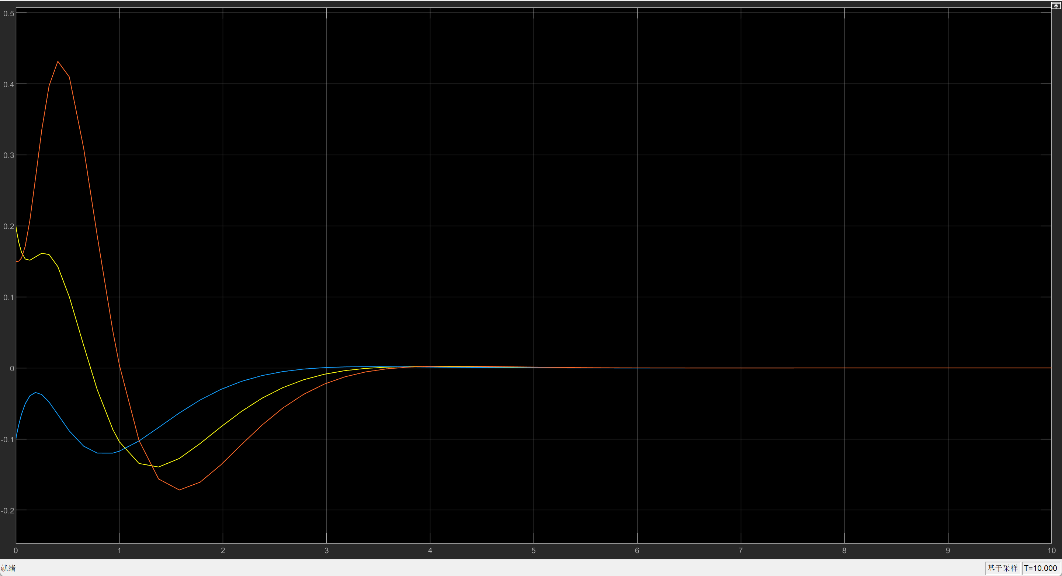

The six state responses with non-zero initial state but zero input is shown in Fig.

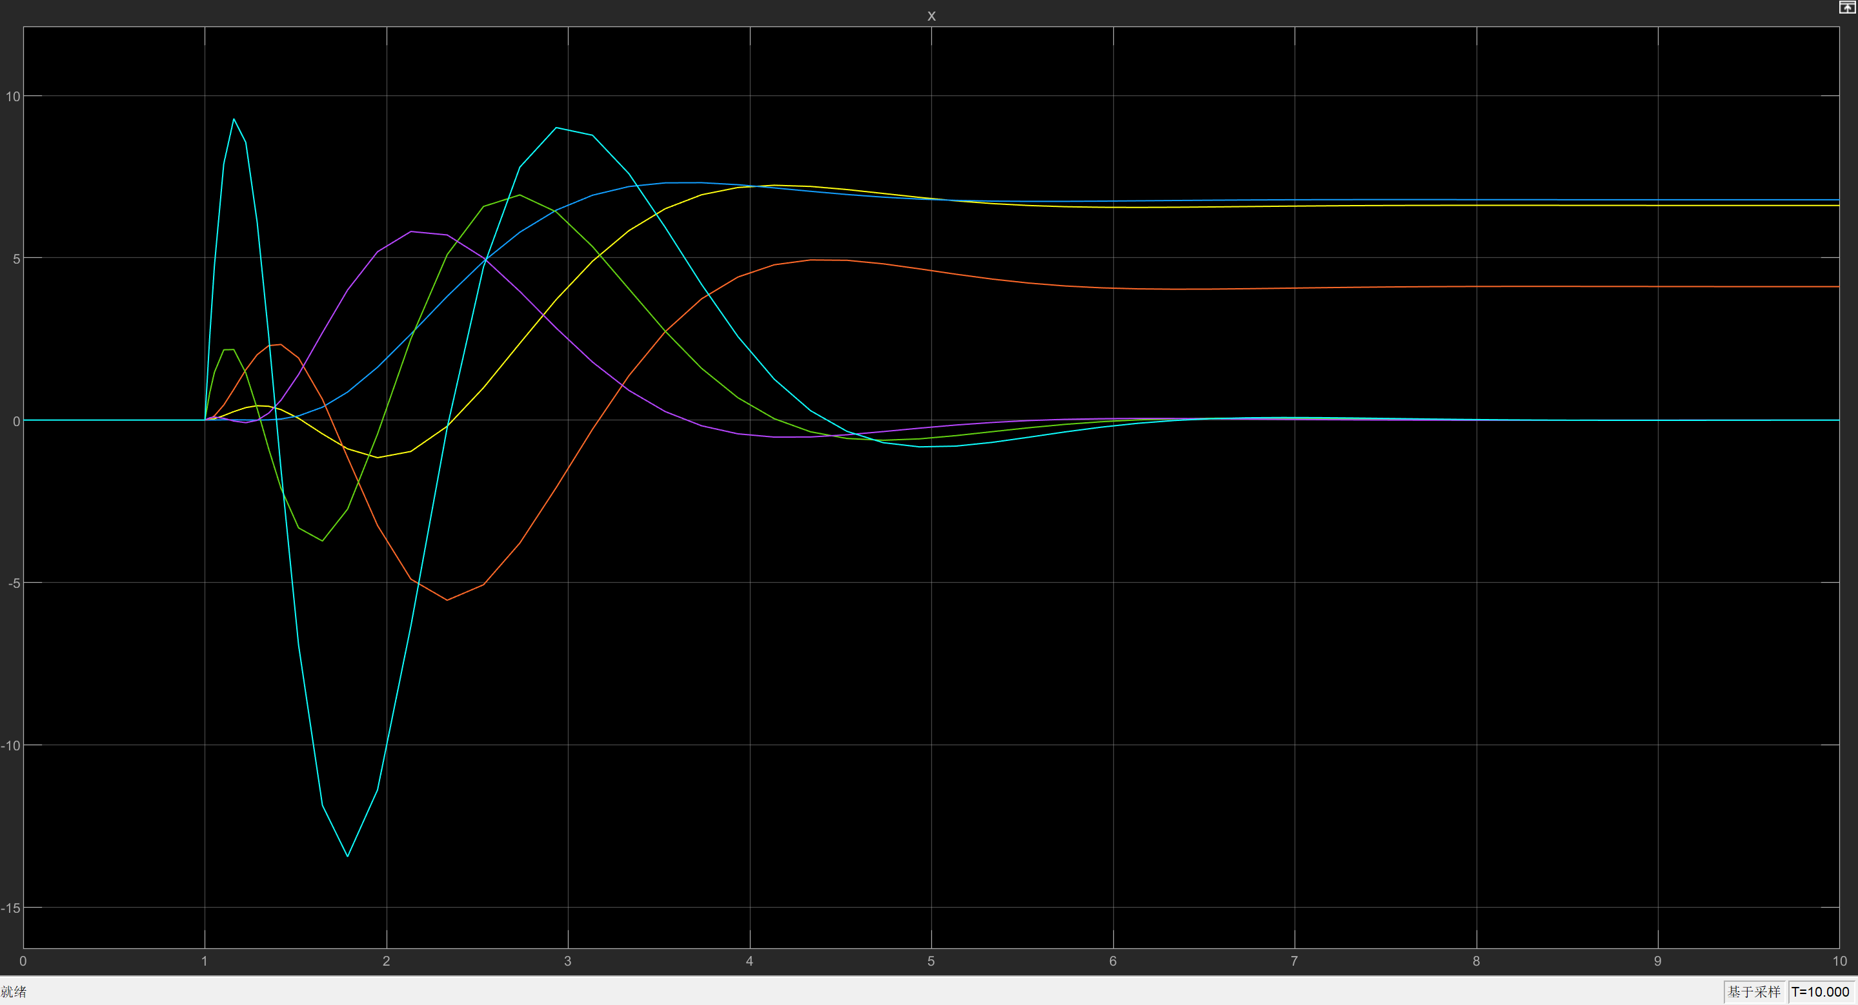

* + 1. **Position of Poles, System Performance and Control Signal Magnitude**

Choose different sets of stable poles as shown in Table to examine the effect of pole positions on the system performance and control signal magnitude.

For the system performance, it can be seen from Fig to Fig that when the dominant poles are farer from the original point in s-plane, the more stable the system transient response is. This is to say that the overshoot is lower with a shorter setting time.

As for the size of the control signal showing from Fig to Fig, the control signal size is smaller for a pole away from the origin of the s-plane.

|  |  |  |  |  |  |  |
| --- | --- | --- | --- | --- | --- | --- |
| Poles Sets |  |  |  |  |  |  |
| Set 1 |  |  |  |  |  |  |
| Set 2 |  |  |  |  |  |  |
| Set 3 |  |  |  |  |  |  |
|  |  |  |  |  |  |  |
|  |  |  |  |  |  |  |
|  |  |  |  |  |  |  |

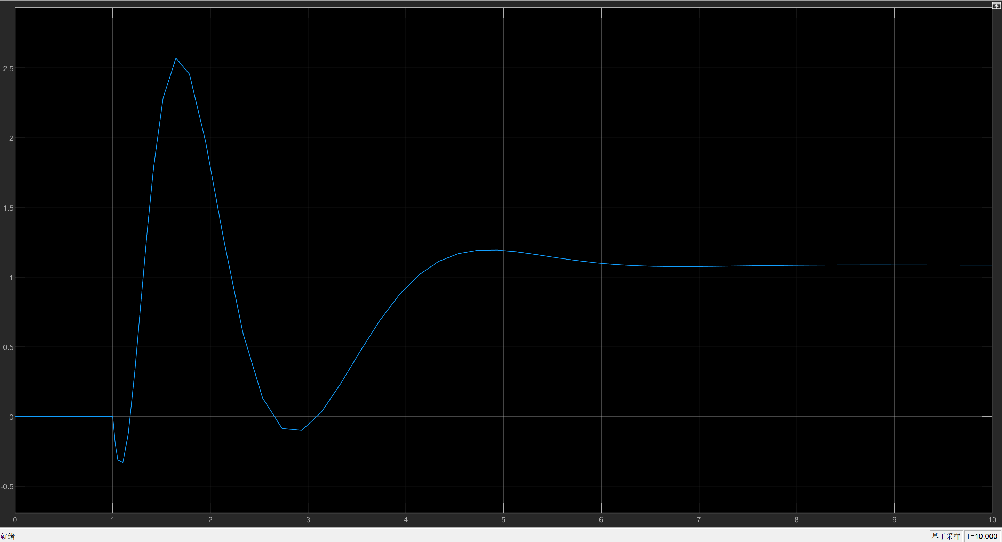

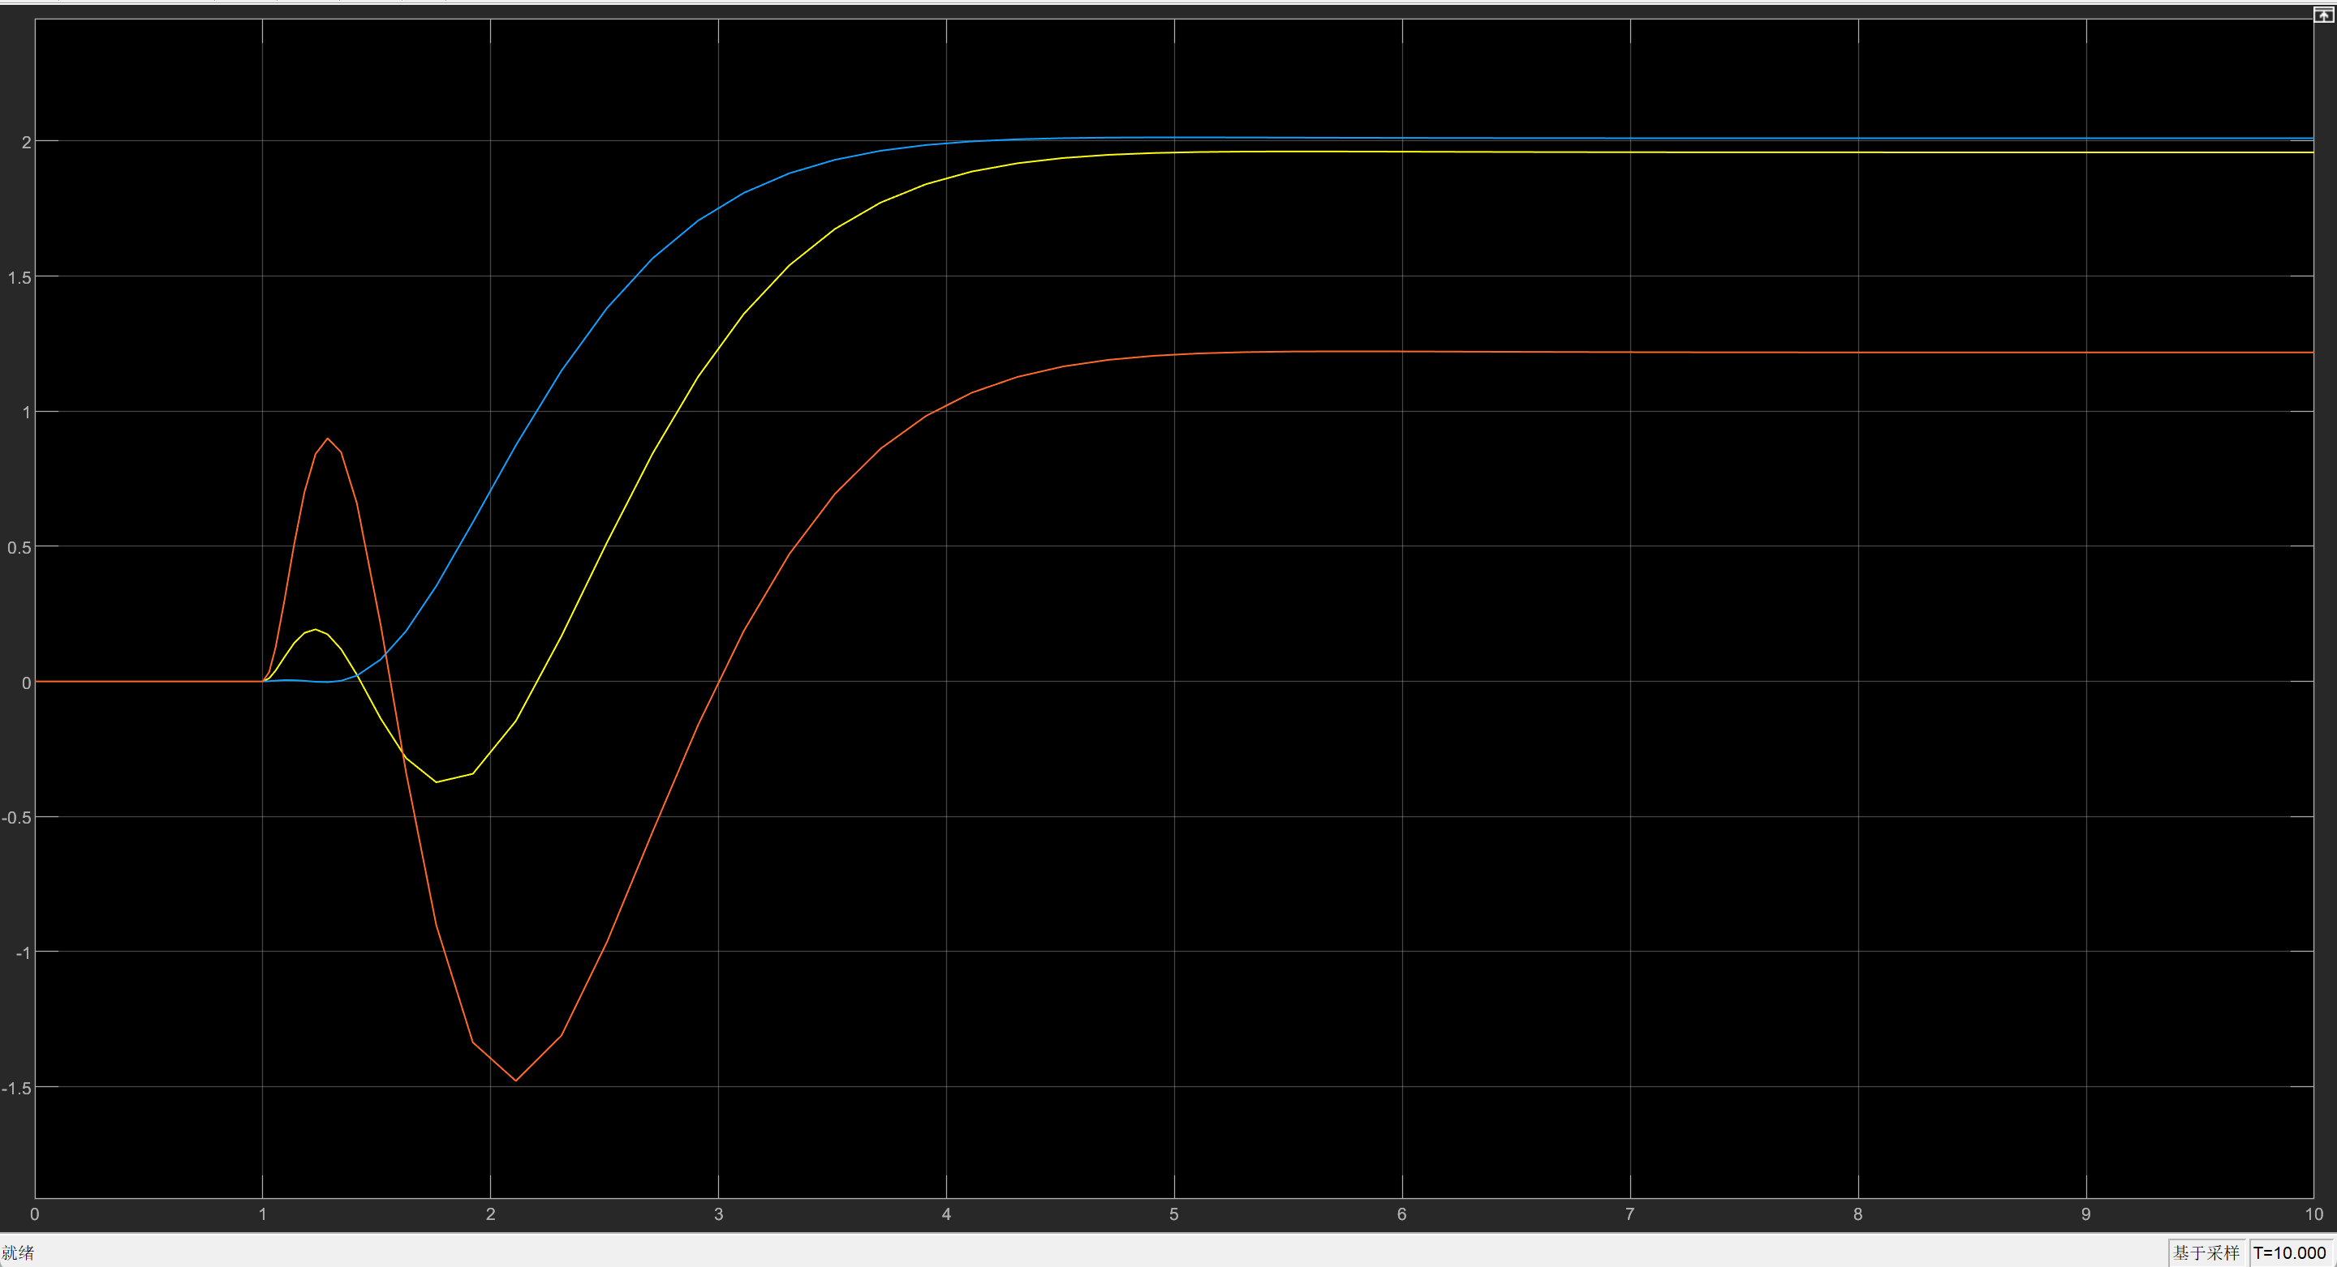

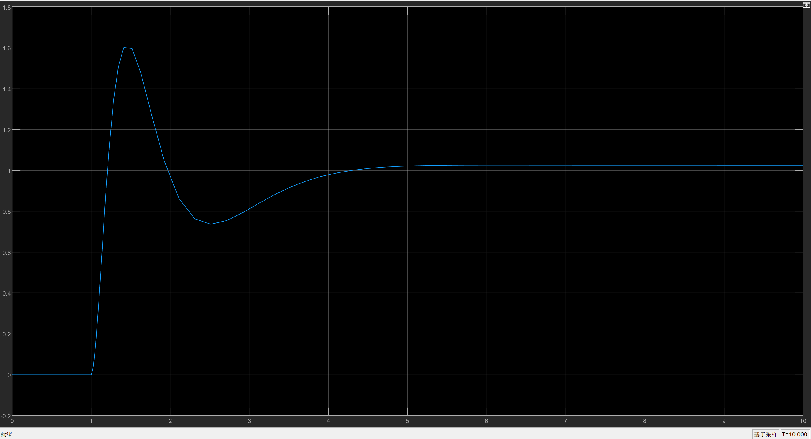

* 1. Control By All State Variables Using LQR
     1. Controller Design
     2. Simulation Results:

The simulation result for initial state and zero input is as shown in Fig:

* + 1. The Effect of Weightings Q and R on System Performance and Control Signal Magnitude
  1. State Estimation with All Output
     1. Observer Design
     2. Simulation Results:

The simulation result for initial state and zero input is as shown in Fig:

* + 1. The Effect of Observer Poles on State Estimation Error and Closed-Loop System Performance
  1. Decoupling Control with Two Output
     1. Decoupling Controller Design
     2. Simulation Results and Internally Stability

Transient responses with zero initial state

Initial responses with respect to initial state

* 1. Servo Control for a Setpoint
     1. Controller Design
     2. Observer Design
     3. Simulation Results
  2. Setpoint Problem for Servo Control

1. Conclusion

Appendices